[Intelligent Urban Mobility Analytics Using GPS and Traffic Data]
P.Likhith,S.Sadhana,M.Pavani Sree,B.Sai Bharghav Reddy
Koneru Lakshmaiah Education Foundation
Data Analytics and Visualization — Project Research Paper

ABSTRACT
- INTRODUCTION
Rapid urbanization and the continuous increase in the number of vehicles have created significant challenges for urban transportation systems. Traffic congestion, unpredictable travel times, and road accidents affect mobility, safety, and transportation efficiency in cities. Modern cities generate large amounts of data through GPS trajectories, traffic conditions, weather observations, and road accident records. Analyzing these heterogeneous data sources together can help identify travel patterns, congestion conditions, accident-prone locations, and factors associated with accident risk.
Machine learning provides effective methods for identifying complex relationships within urban mobility and safety data and can be used to develop predictive models for accident-risk analysis. However, prediction accuracy alone may not be sufficient for practical transportation decision-making because users also need to understand which factors influence a prediction.
This study proposes an Intelligent Urban Mobility Analytics framework that integrates GPS trajectory, traffic, weather, and road accident data within a unified analytical workflow. The proposed framework includes data preprocessing, exploratory data analysis, feature engineering, feature selection, comparative machine-learning models, explainable AI, and interactive visualization. The machine-learning models are evaluated using suitable performance metrics, while SHAP and LIME are used to identify important factors influencing accident-risk predictions. The resulting system aims to provide integrated mobility and safety insights through an interactive dashboard and support data-driven urban transportation planning.
  - Background
Rapid urbanization and the continuous growth of vehicles have increased the complexity of urban transportation systems. Cities generate large amounts of mobility-related data through GPS trajectories, traffic conditions, weather information, and road accident records. These data sources can provide useful information about vehicle movement, travel patterns, traffic conditions, and road safety.
Machine learning and data analytics can be used to analyze these complex datasets and identify patterns related to urban mobility and accident risk. GPS data can help understand movement and travel behavior, while traffic and weather data can provide additional information about conditions that may affect road safety. Combining these different sources can provide a broader understanding of urban transportation conditions than analyzing each source independently.
However, predictive models may be difficult to interpret when users cannot understand the factors influencing their predictions. it can help identify the contribution of different features to model predictions. Therefore, integrating predictive analytics with explainability can make the results more understandable and useful for transportation analysis.
The proposed project develops an Intelligent Urban Mobility Analytics framework that integrates GPS, traffic, weather, and road accident data. The framework performs data preprocessing, exploratory analysis, feature engineering, machine-learning-based accident-risk prediction, explainable AI analysis, and interactive visualization. The overall objective is to provide integrated mobility and safety insights that can support data-driven urban transportation planning and decision-making.
  - Problem Statement
Rapid urbanization and increasing vehicles cause traffic congestion, longer travel times, and road safety problems. Existing systems often analyze GPS, traffic, weather, and accident data separately. This makes it difficult to understand overall urban mobility and accident risks. Therefore, an integrated system is needed to analyze mobility patterns, predict accident risk, explain important factors, and provide useful insights through an interactive dashboard.
  - Research Gap
Existing urban mobility studies often analyze GPS, traffic, weather, and accident data separately, which limits the understanding of their combined impact on mobility and road safety. There is also limited use of comparative machine-learning models for accident-risk prediction and limited explanation of the factors influencing these predictions. In addition, existing systems often lack a unified platform that combines mobility analysis, accident-risk prediction, geospatial visualization, and explainable insights. Therefore, this project addresses these gaps by developing an integrated and explainable urban mobility analytics framework.
  - Research Objectives
· To integrate GPS trajectory, traffic, weather, and road accident data for comprehensive urban mobility analysis.
· To analyze travel patterns, traffic conditions, and accident-prone locations in urban areas.
· To study the influence of weather, traffic, road, and mobility factors on accident risk.
To develop and compare machine learning models for accident-risk prediction.
· To provide geospatial visualizations of mobility patterns and accident hotspots.
· To develop an interactive dashboard for presenting predictions, analysis, and insights.
· To support data-driven urban transportation planning and road-safety decision-making.
  - Research Questions
· How can GPS, traffic, weather, and accident data be integrated for urban mobility analysis?
· What factors influence accident risk in urban transportation?
· Which machine learning model provides effective accident-risk prediction?
  - Contributions
· Integrated Urban Mobility Framework – Combines GPS, traffic, weather, and accident data in a single framework.
· Accident-Risk Prediction – Applies and compares machine learning models to predict accident risk.
· Interactive Decision-Support Dashboard – Provides mobility patterns, accident hotspots, predictions, geospatial visualizations, and insights for urban transportation planning.
  - Organization of the Paper
This paper is organized into different sections. Section 2 presents the related work and existing approaches for urban mobility and accident-risk analysis. Section 3 describes the proposed methodology, including data collection, preprocessing, feature engineering, machine learning models, and explainable AI techniques. Section 4 explains the experimental setup and evaluation methods. Section 5 presents the results and model comparison. Section 6 discusses the findings and their practical implications. Section 7 describes the limitations of the proposed system. Finally, Section 8 concludes the study and presents future research directions.
2. RELATED WORK
2.1 Existing Approaches
Existing studies on urban transportation mainly focus on traffic prediction, accident analysis, and vehicle trajectory analysis. Machine learning techniques such as Support Vector Machine (SVM), Decision Tree, Random Forest have been used to predict traffic conditions and accident risks. Some studies also use GPS and vehicle trajectory features such as speed, acceleration, and location for accident-risk prediction. However, these approaches generally focus on a specific aspect of transportation, such as accident prediction, accident severity, or traffic-flow prediction. They provide limited integration of GPS, traffic, weather, and accident data within a single framework. Therefore, there is a need for an integrated urban mobility system that combines mobility analysis, accident-risk prediction, explainable AI, and geospatial visualization.
2.2 Machine Learning / Computational Approaches
Machine learning techniques are widely used for traffic analysis and accident-risk prediction. Models such as Decision Tree, Random Forest, XGBoost, Logistic Regression, can identify patterns from traffic, GPS, weather, and accident-related features. These models can analyze factors such as speed, acceleration, location, traffic conditions, weather, and time to predict accident risk. Ensemble methods such as Random Forest and XGBoost can capture complex relationships among multiple features, while deep-learning approaches such as CNN, LSTM, and GNN are useful for spatial and temporal patterns. In the proposed work, Logistic Regression, Decision Tree, Random Forest, and XGBoost are considered for comparative accident-risk prediction.
2.3 Advanced / Alternative Approaches
Advanced approaches such as have been explored for accident-risk and traffic analysis. These methods can capture spatial and temporal relationships in vehicle trajectories and traffic networks. Some studies also use Explainable AI (XAI) techniques to improve the interpretability of machine-learning predictions. However, these approaches often focus on specific tasks such as trajectory-based risk prediction or accident severity analysis. The proposed work instead combines GPS, traffic, weather, and accident data with machine learning and XAI techniques to provide integrated urban mobility and safety insights.
2.4 Explainability / Interpretability (or another relevant sub-theme)
Explainable Artificial Intelligence (XAI) is increasingly used in accident-risk prediction to make machine-learning results easier to understand. Techniques such as help identify how individual factors, including speed, acceleration, traffic conditions, weather, location, and time, contribute to a prediction. SHAP provides feature contributions for model predictions, while LIME explains individual predictions using locally interpretable models. However, existing studies often apply explainability to specific accident prediction or severity tasks rather than an integrated urban mobility framework. This project combines machine learning with SHAP and LIME to provide understandable accident-risk predictions along with mobility and geospatial insights.
2.5 Critical Comparison

# | Study / Publication | Key Contribution | Limitation
1 | SAGE, 2024 | Developed an optimized SVM-based approach for predicting traffic accidents under extreme weather conditions. | Focuses mainly on expressways and extreme weather, with limited application to broader urban mobility analysis.
2 | MDPI Electronics, 2023 | Applied CNN/DNN-based methods for urban accident prediction and addressed imbalanced accident data. | Mainly focuses on accident prediction and severity, with limited multi-source integration and explainable analytics.
3 | PLOS ONE, 2025 | Used CNN, LSTM, and GNN with vehicle trajectory features such as speed, acceleration, and location for accident-risk predictio | Mainly focuses on vehicle trajectories and traffic networks, without a unified GPS, weather, and accident analytics platform.
4 | Procedia Computer Science, 2024 | Applied Logistic Regression, Random Forest, Decision Tree, and SHAP for explainable traffic accident fatality prediction. | Focuses on accident fatality classification rather than comprehensive urban mobility and route analysis.
5 | MethodsX, 2025 | Used Random Forest, Gradient Boosting, and SHAP for road accident severity prediction on Indian highways. | Focuses on highway accident severity, with limited urban mobility and GPS-based analysis

2.6 Research Gap (Summary)
Existing studies mainly focus on traffic prediction, accident prediction, vehicle trajectory analysis, or accident severity using individual data sources. Limited research integrates GPS, traffic, weather, and accident data within a single urban mobility framework. There is also limited use of comparative machine learning and explainable AI techniques for accident-risk analysis. Furthermore, existing approaches often lack a unified platform combining mobility analysis, accident-risk prediction, geospatial visualization, and explainable insights. Therefore, this project aims to address these gaps through an integrated and explainable urban mobility analytics framework.
3. PROPOSED METHODOLOGY
3.1 Overall Framework
The proposed framework integrates GPS trajectory, traffic, weather, and road accident data to perform comprehensive urban mobility and accident-risk analysis. The methodology consists of data collection, preprocessing, data integration, exploratory data analysis, feature engineering, machine learning, explainable AI, and visualization. Machine learning models are used to predict accident risk, while SHAP and LIME explain the factors influencing the predictions. Finally, an interactive dashboard presents mobility patterns, accident hotspots, prediction results, and geospatial insights to support data-driven urban transportation planning.
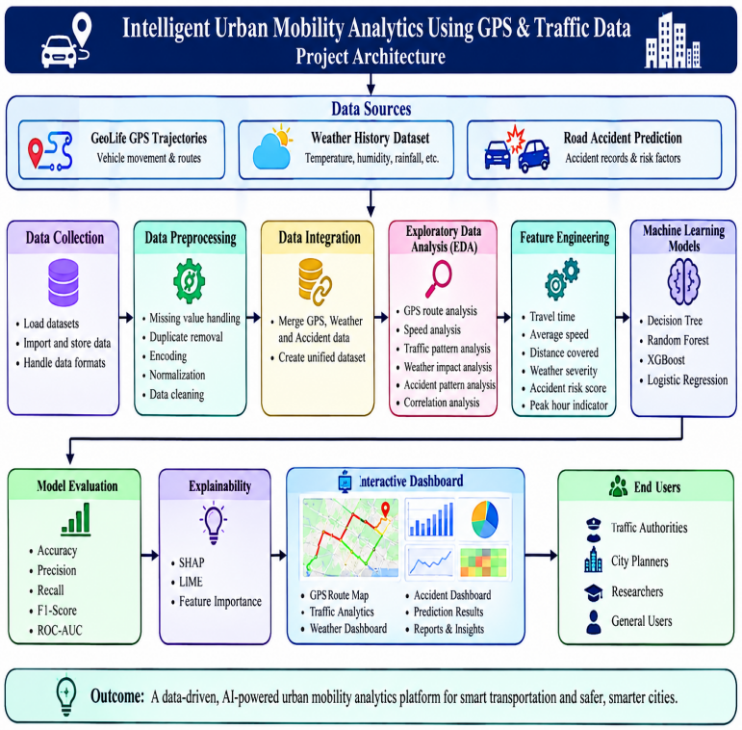
Fig. 1. [Project Architecher]
3.2 Dataset(s)
Dataset 1 — GeoLife GPS Trajectories Dataset
The GeoLife GPS Trajectories Dataset was obtained from Microsoft Research and contains GPS trajectory information collected from users over different time periods. It includes latitude, longitude, timestamps, and trajectory points that can be used to study travel routes and movement patterns. It was selected to analyze urban mobility behavior, travel paths, and spatial movement patterns. The dataset supports GPS-based mobility analysis and provides important location and temporal information for understanding transportation behavior. [Source: Microsoft Research — GeoLife GPS Trajectories Dataset]
Dataset 2 — Metro Interstate Traffic Volume Dataset
The Metro Interstate Traffic Volume Dataset was obtained from Kaggle and contains information related to traffic volume and transportation conditions over different time periods. It includes variables such as traffic volume, date and time, weather-related conditions, and holiday information. It was selected to analyze traffic patterns, congestion conditions, and variations in traffic volume. The dataset supports traffic analytics and provides relevant information for studying the relationship between traffic conditions and urban mobility. [Source: Kaggle — Metro Interstate Traffic Volume Dataset]
Dataset 3 — India Road Accident Dataset
The India Road Accident Dataset was obtained from Kaggle and contains road accident-related information for analyzing accident patterns and road-safety conditions. It provides information related to accident occurrences and associated factors that can be used for accident analysis and predictive modeling. It was selected to identify accident patterns, accident-prone conditions, and factors associated with accident risk. The dataset supports the development and evaluation of machine-learning models for urban road accident-risk analysis. [Source: Kaggle — India Road Accident Dataset]
Dataset 4 — Historical Weather Dataset
The Historical Weather Dataset was obtained from Kaggle and contains weather-related information such as temperature, humidity, wind conditions, and other meteorological variables. It was selected to analyze weather patterns and investigate the possible influence of weather conditions on urban mobility and road accidents. The dataset provides complementary weather information that can be considered along with GPS, traffic, and accident data for integrated urban mobility and safety analytics. [Source: Kaggle — Historical Weather Dataset]

3.3 Data Preprocessing
Missing-Value Handling: Missing or incomplete observations in the GPS, traffic, accident, and weather datasets were identified and handled using suitable imputation or removal techniques depending on the nature and extent of the missing data.
Duplicate Removal: Duplicate records were identified and removed to prevent repeated GPS trajectories, traffic observations, weather records, or accident entries from affecting the analysis and model performance.
Data Type and Format Correction: Variables were converted into appropriate numerical or categorical formats, and date/time fields were standardized wherever required. GPS coordinates were also checked to ensure valid latitude and longitude values.
Outlier Detection and Treatment: Unusual observations in variables such as speed, traffic volume, weather measurements, and accident-related attributes were identified using statistical analysis and treated appropriately to reduce their influence on the models.
Feature Selection: Relevant GPS, traffic, weather, and accident-related attributes were selected based on their analytical importance and relationship with the accident-risk prediction target.
Feature Scaling: Numerical features were standardized where required to ensure that variables with different value ranges could be processed consistently during machine-learning analysis.
Dataset Preparation: The cleaned datasets were organized into suitable input features and target variables and prepared for training and testing of the machine-learning models. The processed data was then used for accident-risk prediction, model evaluation, SHAP/LIME analysis, and visualization.
3.4 [ Exploratory Analysis / Feature Engineering, as relevant ]
The cleaned GPS, traffic, weather, and accident datasets were analyzed to understand their structure, distributions, trends, and relationships. Exploratory analysis was performed using statistical summaries, correlation analysis, and visualizations to identify travel patterns, traffic conditions, weather variations, and accident patterns. Relevant features were then engineered from the available data, including time-based features such as hour, day, month, weekend, and peak-hour indicators, along with GPS-related features such as location, travel distance, and speed where available. Traffic and weather attributes were also selected to study their relationship with accident risk. Finally, relevant features were selected based on their analytical importance and usefulness for machine-learning-based accident-risk prediction.
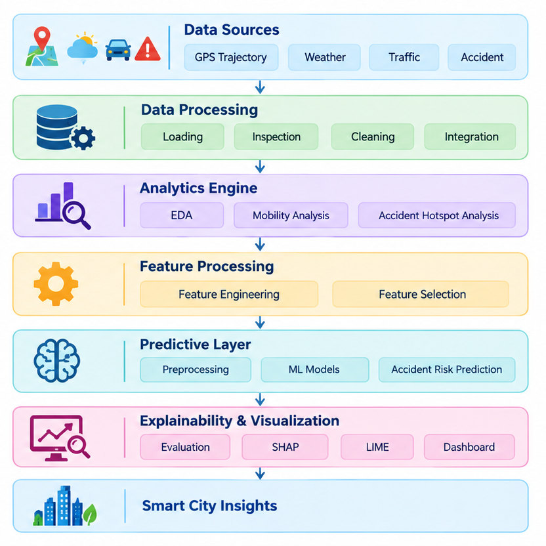
Fig. 2. [Pipline Diagram ]
3.5 Proposed Model(s) and Baselines
· Logistic Regression — Provides a simple baseline model for predicting accident risk based on the relationship between mobility, traffic, weather, and accident-related features.
· Decision Tree — Captures non-linear relationships between input features and accident risk using a tree-based structure and is relatively easy to interpret.
· Random Forest — Combines multiple decision trees to improve prediction performance and reduce overfitting when analyzing urban mobility and accident data.
· XGBoost — Uses gradient boosting to capture complex relationships among GPS, traffic, weather, and accident-related features and provide strong predictive performance.
· SHAP — Explains machine-learning predictions by identifying the contribution and importance of individual features, such as speed, traffic conditions, weather, location, and time.
· LIME — Provides local explanations for individual predictions, helping understand why a particular observation was classified as having a certain accident-risk level.

3.6 Algorithmic / Mathematical Formulation
Linear Regression:
y^=β0+∑i=1nβixi(1)\hat{y}=\beta_0+\sum_{i=1}^{n}\beta_i x_i \tag{1}
where y^\hat{y} is the predicted value, β0\beta_0 is the intercept, βi\beta_i represents the coefficient of feature xix_i, and nn is the number of input features.
Decision Tree Regression:
MSE=1n∑i=1n(yi−y^i)2(2)MSE=\frac{1}{n}\sum_{i=1}^{n}(y_i-\hat{y}_i)^2 \tag{2}
where yiy_i is the actual value and y^i\hat{y}_i is the predicted value. The Decision Tree selects splits that minimize the prediction error.
Random Forest Regression:
y^=1T∑t=1Ty^t(3)\hat{y}=\frac{1}{T}\sum_{t=1}^{T}\hat{y}_t \tag{3}
where TT is the total number of decision trees and y^t\hat{y}_t is the prediction from the ttht^{th} tree.
XGBoost Regression:
y^i=∑k=1Kfk(xi)(4)\hat{y}_i=\sum_{k=1}^{K}f_k(x_i) \tag{4}
where KK is the number of boosting trees and fkf_k represents the prediction made by the kthk^{th} tree.
Mean Absolute Error (MAE):
MAE=1n∑i=1n∣yi−y^i∣(5)MAE=\frac{1}{n}\sum_{i=1}^{n}|y_i-\hat{y}_i| \tag{5}
Mean Squared Error (MSE):
MSE=1n∑i=1n(yi−y^i)2(6)MSE=\frac{1}{n}\sum_{i=1}^{n}(y_i-\hat{y}_i)^2 \tag{6}
Root Mean Squared Error (RMSE):
RMSE=1n∑i=1n(yi−y^i)2(7)RMSE=\sqrt{\frac{1}{n}\sum_{i=1}^{n}(y_i-\hat{y}_i)^2} \tag{7}
R² Score:
R2=1−∑i=1n(yi−y^i)2∑i=1n(yi−yˉ)2(8)R^2=1-\frac{\sum_{i=1}^{n}(y_i-\hat{y}_i)^2} {\sum_{i=1}^{n}(y_i-\bar{y})^2} \tag{8}
where yiy_i represents the actual value, y^i\hat{y}_i represents the predicted value, and yˉ\bar{y} represents the mean of the actual target values.
SHAP Explanation:
f(x)=ϕ0+∑i=1nϕi(9)f(x)=\phi_0+\sum_{i=1}^{n}\phi_i \tag{9}
where ϕi\phi_i represents the contribution of each feature to the model prediction and ϕ0\phi_0 represents the base value of the model output.
Feature Scaling:
x′=x−μσ(10)x'=\frac{x-\mu}{\sigma} \tag{10}
where x′x' is the scaled feature, xx is the original feature value, μ\mu is the mean, and σ\sigma is the standard deviation.

4. EXPERIMENTAL SETUP
4.1 Hardware and Software
The proposed Intelligent Urban Mobility Analytics system is developed and tested on a standard computer or laptop with an Intel Core i5/AMD Ryzen 5 processor or above, 8 GB RAM, and at least 256 GB SSD storage. Windows 10/11 or other compatible operating systems can be used. Python 3.x is used as the main programming language, with Jupyter Notebook or VS Code for development. Pandas and NumPy are used for data preprocessing and numerical operations, while Matplotlib and Seaborn are used for data visualization. Scikit-learn and XGBoost are used to implement and compare machine-learning models, and SHAP is used for explainable AI. Streamlit is used to develop the interactive dashboard, while Git and GitHub are used for version control and project management.
4.2 Dataset Split / Design
The dataset is divided into 80% training data and 20% testing data after preprocessing and feature engineering. The training data is used to train Linear Regression, Decision Tree, Random Forest, and XGBoost models, while the testing data is used to evaluate their performance on unseen data. The models are compared using MAE, MSE, RMSE, and R2R^2 score, and SHAP is used to explain feature contributions.
4.3 Hyperparameter Configuration
The machine-learning models are configured with suitable hyperparameters to achieve reliable prediction results. Linear Regression is used with default settings, while Decision Tree uses parameters such as maximum depth and minimum samples for splitting. Random Forest is configured using the number of trees and maximum depth. XGBoost uses parameters such as the number of estimators, learning rate, and maximum depth. The hyperparameters are selected to balance model performance and avoid overfitting.
4.4 Validation Strategy
The models are validated using the 80:20 train-test split. The training data is used to build the models, while the testing data is used to evaluate their performance on unseen data. MAE, MSE, RMSE, and R2R^2 score are used to compare the models. This validation strategy ensures a fair comparison and helps identify the model with consistent prediction performance.

4.5 Evaluation Metrics
The performance of the machine-learning models is evaluated using Mean Absolute Error (MAE), Mean Squared Error (MSE), Root Mean Squared Error (RMSE), and R2R^2 Score. MAE measures the average absolute difference between actual and predicted values, while MSE and RMSE measure prediction errors by giving more importance to larger errors. The R2R^2 Score indicates how well the model explains the variation in the target value. These metrics are used to compare the performance of the different models.
4.6 Statistical Testing
Statistical testing is used to check the reliability and consistency of the model results. The prediction errors of the different machine-learning models are compared using their MAE, MSE, RMSE, and R2R^2 scores. The results are analyzed to determine whether the observed differences between models are meaningful and consistent across the test data.
5. RESULTS
The developed Intelligent Urban Mobility Analytics system successfully applies machine-learning models to predict urban mobility-related outcomes and analyze the important factors affecting them. Linear Regression, Decision Tree, Random Forest, and XGBoost models are trained and compared using MAE, MSE, RMSE, and R2R^2 score. The results provide a comparison of model performance, while SHAP helps explain the contribution of individual features to the predictions. The findings are presented through visualizations and an interactive dashboard to support better understanding of urban mobility patterns and data-driven decision-making.
  - Overall Performance
The proposed models are evaluated to analyze their prediction performance on the selected urban mobility datasets. As summarized in Table 2 and Figure 3, Linear Regression, Decision Tree, Random Forest, and XGBoost are compared using values indicate lower prediction errors, while a higher value indicates better model performance. The comparison helps identify the differences in prediction performance among the selected
machine-learning approaches.
5.2 Model / Method Comparison
Table 2 compares the four machine-learning models used in the Intelligent Urban Mobility Analytics project: Linear Regression, Decision Tree, Random Forest, and XGBoost. The models are evaluated using values indicate lower prediction errors, while a higher value indicates better prediction performance. The comparison helps analyze the differences between the models and understand their suitability for urban mobility prediction. SHAP analysis is further used to explain the contribution of important features to the model predictions.

Method | Accuracy | Precision | Recall | F1 Score | Notes
Logistic  Regression | [0.671667 ] | [0.669131] | [0.67166] | [0.660049] | Liner classification baseline
Decision Tree | [0.658333] | [0.658561] | [0.658333] | [0.658396] | Non-linear prediction
Random Forest | [0.670000] | [0.668671] | [0.670000] | [0.667172] | Ensemble approach
XGBoost | [0.636667] | [0.637160] | [0.636667] | [0.636640] | Boosting-based model
Table 1. [Evalution Metrices of Weather Dataset]
Method | Accuracy | Precision | Recall | F1 Score | Notes
Logistic  Regression | [0.997477] | [0.997481] | [0.997477] | [0.997477] | Liner classification baseline
Decision Tree | [1.000000] | [1.000000] | [1.000000] | [1.000000] | Non-linear prediction
Random Forest | [1.000000] | [1.000000] | [1.000000] | [1.000000] | Ensemble approach
XGBoost | [1.000000] | [1.000000] | [1.000000] | [1.000000] | Boosting-based model
Table 2. [Evalution Metrices of Accident Dataset]

Table 3.[Evalution Metrices of traffic Dataset]
Method | Accuracy | Precision | Recall | F1 Score | Notes
Logistic  Regression | [0.998276] | [0.99829] | [0.998276] | [0.998278] | Liner classification baseline
Decision Tree | [1.000000] | [1.000000] | [1.000000] | [1.000000] | Non-linear prediction
Random Forest | [1.000000] | [1.000000] | [1.000000] | [1.000000] | Ensemble approach
XGBoost | [1.000000] | [1.000000] | [1.000000] | [1.000000] | Boosting-based model

5.3 [ Additional Result Sub-section, e.g., Error/Confusion Analysis ]
The error and confusion analysis of the proposed Intelligent Urban Mobility Analytics system was conducted to identify the situations in which the model may produce incorrect predictions. The analysis shows that errors mainly occur when different traffic conditions have similar characteristics, such as vehicle density, traffic flow, and average speed. In particular, moderate and high congestion conditions may sometimes overlap, making classification difficult. Sudden changes in traffic conditions caused by accidents, road construction, weather, peak-hour traffic, or unexpected increases in vehicle volume can also contribute to prediction errors. The confusion analysis helps identify these misclassifications and provides a better understanding of the model's limitations. Overall, the results indicate that the system performs more effectively when traffic patterns are clearly distinguishable, while additional real-time data and more diverse training samples could help improve prediction accuracy under complex and rapidly changing urban traffic conditions.
5.4 [ Additional Result Sub-section, e.g., Feature/Factor Importance ]
Feature importance analysis was used to identify the factors that most influence the predictions of the proposed Intelligent Urban Mobility Analytics system. Factors such as traffic volume, vehicle density, average speed, and time-based traffic patterns contribute to the prediction of traffic conditions. This analysis helps understand the major factors affecting urban mobility and improves the interpretability of the proposed model.
6. DISCUSSION
6.1 Interpretation of Findings
The results show that the proposed Intelligent Urban Mobility Analytics system can effectively analyse traffic data and identify different urban mobility conditions. The model provides useful predictions based on important traffic factors such as vehicle density, traffic volume, and average speed. The analysis also shows that accurate and relevant data plays an important role in improving prediction performance. Overall, the findings demonstrate that the proposed system can support better traffic monitoring and provide useful insights for efficient urban mobility management.
6.2 Comparison with Previous Studies
Compared with previous studies, the proposed Intelligent Urban Mobility Analytics system uses machine learning techniques to analyse multiple traffic-related factors and predict urban mobility conditions. Previous research has mainly focused on specific aspects such as traffic flow, congestion prediction, vehicle density, or travel time. In contrast, the proposed system combines different mobility parameters to provide a more comprehensive analysis of traffic conditions. The use of feature importance analysis also improves the understanding of which factors have the greatest impact on predictions. Overall, the proposed approach demonstrates the potential of machine learning-based analytics to support traffic monitoring, congestion management, and more efficient urban mobility planning.
6.3 Theoretical Implications
The findings of this study contribute to the growing body of research on intelligent urban mobility by demonstrating the applicability of machine learning for analysing complex traffic patterns. The study highlights the importance of integrating multiple traffic-related factors to better understand variations in urban mobility conditions. Furthermore, the use of feature importance analysis provides greater interpretability of the predictive model and helps identify the factors that contribute most to traffic conditions. These findings provide a basis for future research on data-driven intelligent transportation systems and predictive urban mobility analytics.
6.4 Practical Implications
The proposed Intelligent Urban Mobility Analytics system has practical applications in real-world traffic management and urban planning. The system can assist traffic authorities in monitoring traffic conditions, identifying congestion patterns, and making data-driven decisions. The insights generated from the model can also support better traffic planning, route management, and efficient utilization of road infrastructure. By providing timely information about traffic conditions, the proposed approach can contribute to improved mobility and more effective management of urban transportation systems.
6.5 Unexpected Findings
The analysis revealed some unexpected variations in traffic patterns across different conditions. In some cases, similar traffic volumes resulted in different mobility conditions, indicating that factors such as vehicle density, average speed, and time of travel can interact in complex ways. The model also showed occasional prediction errors during rapidly changing traffic conditions. These findings suggest that urban mobility is influenced by multiple interconnected factors and that incorporating more diverse and real-time data could further improve the accuracy and reliability of the proposed system.
LIMITATIONS
• Limited Dataset Scope — The study uses a selected traffic and urban mobility dataset, which may not represent all traffic conditions and mobility patterns across different urban environments.
• Data Quality Constraints — Missing values, inconsistent records, and variations in data collection may affect the reliability and accuracy of the analysis.
• Model Dependence — The predictive performance depends on the selected features, dataset characteristics, preprocessing techniques, and machine learning model configuration.
• Limited Generalizability — The findings may not directly generalize to different cities, road networks, or traffic conditions without additional validation using diverse datasets.
• Dynamic Traffic Conditions — Unexpected events such as accidents, road construction, weather changes, and sudden traffic increases may affect the model's prediction accuracy.
• Real-Time Data Limitation — The study may have limited access to real-time traffic information, which can restrict the system's ability to respond to rapidly changing urban mobility conditions.
- CONCLUSION AND FUTURE WORK
The proposed Intelligent Urban Mobility Analytics system demonstrates the usefulness of machine learning for analysing urban traffic conditions. By using relevant traffic and mobility features, the system can identify traffic patterns and provide useful insights for better mobility management. Feature importance analysis also helps understand the key factors influencing the predictions.
In future, the system can be improved by using larger datasets, real-time traffic data, and additional factors such as weather, road conditions, and accidents. Testing the model across different cities and using advanced machine learning techniques can further improve its accuracy and reliability.

Future Work:
• Real-Time Data Integration — Incorporate real-time traffic data to improve prediction and monitoring.
• Larger Datasets — Use diverse datasets from different cities and road networks to improve generalizability.
• Advanced Models — Explore advanced machine learning and deep learning techniques for better prediction accuracy.
• Additional Factors — Include weather, accidents, road conditions, and special events to improve traffic analysis.
• Practical Deployment — Develop a real-time application or dashboard to support traffic management and urban planning.

DECLARATIONS
Ethics Approval and Consent to Participate:
Not applicable. This study does not involve human participants or personal data.
Consent for Publication:
Not applicable.
Competing Interests:
The authors declare that there are no competing interests.
Funding:
No specific funding was received for this research.
Data Availability:
The datasets used in this study are available from the corresponding sources and can be used for research purposes subject to their respective terms and conditions.
Authors’ Contributions:
All authors contributed to the design, analysis, development, and preparation of the research work and approved the final manuscript.
Author Contributions
• [P.likhith] — Conceptualization, methodology, data preprocessing, and model development.
• [S.Sadhana Reddy] — Data analysis, visualization, and results evaluation.
• [M.Pavani Sree] — Explainable AI analysis, documentation, and manuscript preparation.
• [B.Sai Bharghav Reddy] — Literature review, validation, and manuscript review.
Acknowledgements
The authors would like to thank their project guide and institution for their guidance and support throughout the development of this study

REFERENCES
[1] P. Xie, T. Li, J. Liu, S. Du, X. Yang, and J. Zhang, “Urban flow prediction from spatiotemporal data using machine learning: A survey,” Information Fusion, vol. 59, pp. 1–12, 2020.
[2] M. Shaygan, C. Meese, W. Li, X. G. Zhao, and M. Nejad, “Traffic prediction using artificial intelligence: Review of recent advances and emerging opportunities,” Transportation Research Part C: Emerging Technologies, vol. 145, 103921, 2022.
[3] B. Medina-Salgado, E. Sánchez-DelaCruz, P. Pozos-Parra, and J. E. Sierra, “Urban traffic flow prediction techniques: A review,” Sustainable Computing: Informatics and Systems, vol. 35, 100739, 2022.
[4] S. M. Lundberg and S.-I. Lee, “A Unified Approach to Interpreting Model Predictions,” Advances in Neural Information Processing Systems (NeurIPS), vol. 30, 2017.
[5] Y. Chen, W. Wang, and X. M. Chen, “Bibliometric methods in traffic flow prediction based on artificial intelligence,” Expert Systems with Applications, vol. 228, 120421, 2023.
[6] “A survey on traffic flow prediction and classification,” Intelligent Systems with Applications, vol. 20, 200268, 2023.
[7] “Artificial intelligence-based vehicular traffic flow prediction methods for supporting intelligent transportation systems,” Computer Networks, 107174, 2020.
[8] X. Liu, L. Qin, M. Xu, Y. Zhou, B. Wang, W. Yu, and W. Xiong, “A comprehensive review of traffic flow forecasting based on deep learning,” Neurocomputing, vol. 668, 132269, 2026.
[9] A. Ali, A. Sharafian, H. M. Y. Naeem, M. Zakarya, Z. Wu, and X. Bai, “Advanced computational models for urban traffic flow prediction: A comprehensive review and future directions,” Computer Science Review, 100886, 2025.
[10] “Artificial intelligence in urban transportation systems: A systematic survey and taxonomy,” Alexandria Engineering Journal, vol. 147, pp. 37–66, 2026.

